Meta Description:
Dominate your marketing with expert SEO insight on keyword search volume. Be the brand you always dream of with the right strategies that help you get more traffic.

Dominate Your SEO with Expert Insights on Keyword Search Volume

SEO has continued to become a vital component of digital marketing for any organization that wants to outperform its competitors.
Among all aspects of SEO, keyword search volume is what determines the effectiveness of certain keywords in a certain geography.
So, it is necessary to know about all factors that affect such volumes when it comes to the development of an effective organic traffic and brand awareness strategies.
In this blog, we will discuss some of the issues involved in keyword search volumes for you to beat your competitors in SEO.
At the end of reading this guide, you will be in a position to differentiate the what, the how, and the why of assessing and integrating keyword search volume in formulating practical and captivating strategies for the target customer.

What Is Keyword Search Volume?
Keyword search volume means the number of times a single keyword or a phrase is entered by users in a search engine in a month.
This metric is basic to the SEO process and keyword overview because it provides an important understanding about the levels of popularity of specific keywords.
The use of high-volume keywords makes it easier to gain popularity as many people are interested in it, while low-intensity keywords may show that it is a topic which few people are interested in or new trends.

Types of Search Volume:
Let’s talk about two types of search volume that help you understand everything related to it.
Definition of global and local search volumes plays an important role in developing an appropriate SEO strategy for your company:

Global Search Volume:
Global Search Volume is the number of searches that have been made on the global market for a particular keyword.
It is especially beneficial to those companies that market products and services with a large target market in the global market.
High global search volume points out that there is a great demand for the product or service offered by an e-commerce brand or platform across the world.

Local Search Volume:
Another is the ‘Local Search Volume’ that looks at the search volumes within a particular locality.
Local keyword traffic is required for companies that are aiming at providing their services to a particular region or a community.
Using local keywords ensures that your business receives more prominence to prospective buyers in the region in the form of local consumers.

The Importance of Assessing Search Volume:
Keyword metrics is one of the most important terms that helps you assess the search volume of a particular keyword with more effectiveness. To enhance your understanding about search volume, let’s have a look at different importance factors associated with it.
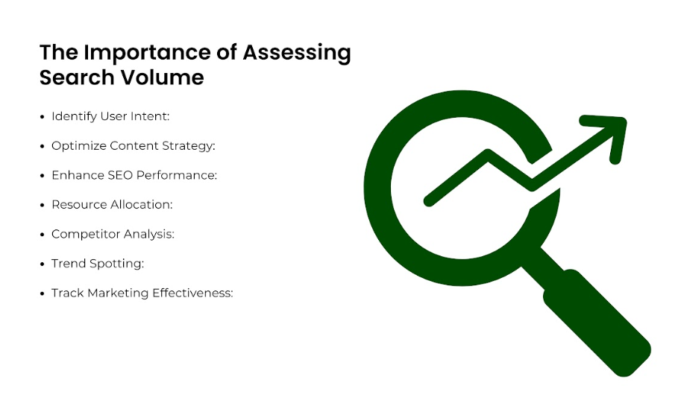

Identify User Intent:
Volume of the search is equivalent to the level of readiness of people to look for specific products.
It makes sense because by examining the volume and the certain patterns of the frequently used keywords, you can understand what the audience is interested in.
Additionally, it further helps in developing content that meets all the targets and preferences of the users, hence improving satisfaction levels of the users.
For example, if there is a search interest in the topic, such as a sudden increase in the search terms like ‘Digital Marketing,’ then content creators are encouraged to create such pieces, such as guides and articles.

Optimize Content Strategy:
Effective content strategy hinges on the judicious selection of keywords with appropriate search volumes.
High search keywords are valuable for traffic if related to the page and target audience, people type them in their search engine bar.
However, what is important is not to overload the website’s keywords with too high frequency keywords along with lesser frequency keywords, while having less chance of being searched for, are likely to elicit higher conversion rates as they are rare.
This balance will mean that search results will be most diverse to address a broad variety of users’ searches or interests.

Enhance SEO Performance:
This is important because the organic process of integrating keywords with a reasonable amount of search queries into the content will improve the overall SEO results.
Commercial and other search engines work in a way that they give preference to the content relevant to the user’s query, and relevant keywords can help your webpage get a better search engine ranking.
The traffic that they get is organic, which is doubled by the increased credibility and authority in the niche.

Resource Allocation:
It is important in managing available marketing resources through the knowledge of the extent of searches made.
Therefore, by identifying the keywords with high search volumes and relative to your business, you can allocate your time and money where it will be most effective.
This way of allocating your marketing efforts is strategic to ensure not only the efficiency but also the cost effectiveness of your campaigns.

Competitor Analysis:
It is crucial to analyze the number of times certain keywords were searched by competitors to analyze their focus.
When using competitors to set standards, you must be aware of certain weaknesses within your competitors' plan to create a competitive edge.
This analysis is beneficial in terms of bringing out the right channel positioning and help in the formulation of unique value propositions that can help you grab the attention of your audience.

Trend Spotting:
Trends indicate variation that can be used in identifying rising changes in the market space.
Through the tracking of these trends, your business can keep up with the changing trends, in a position to adjust the kind of content and even marketing strategies in the flow of the trends.
This is a proactive strategy that not only keeps your content compelling but also makes you an expert in your field of specialization.

Track Marketing Effectiveness:
Fluctuations in search volume indicate that marketing campaigns are effective, to track the progress of current strategies.
When it comes to determining what's next in the cycle of the campaign management, you can rely on the number associated with specific keywords to determine the success of a social networking marketing strategy.
On the other hand, a situation when the search volume either remains at a constant or decreases may signal a need for a change.
This way, the chosen and developed marketing strategies will always be adjusted to your audience needs and current tendencies.

Factors Influencing Monthly Search Volumes:
SEO is not just a hype but a marketing tool that, if well applied, gets a brand to the top most list in the search engine.
In the middle of this approach is keyword search volume, which shows how many times a certain keyword is searched in a given period.
All this information can be highly useful to increase awareness of certain trends, improve the content, and make the right decisions that would improve your website’s ranking.
Nevertheless, some issues may affect such volumes so it is always important to be aware of changes to the trends.
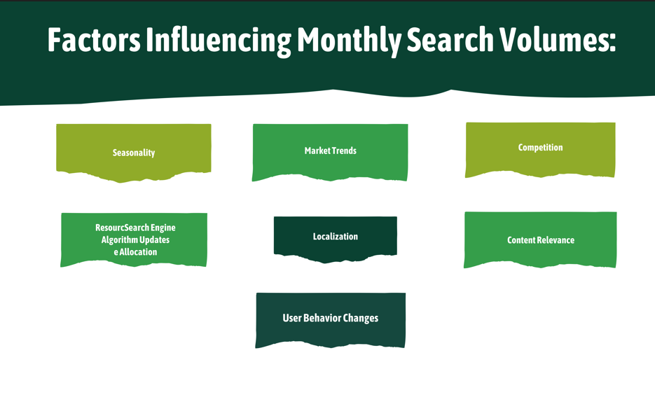

Seasonality:
You must take the seasonality into consideration, as for keyword search volume, it is a very important factor.
As much as the consumers’ behavior changes with the onset of a specific season, so does the nature of used keywords.
Seasonality plays a vital role in the rate at which people search information related to vacation, certain days, and participating in various ceremonies.

- Seasonal Terms: Related to seasons like Holidaying, Christmas, Thanksgiving, Halloween, etc. Such seasonal terms tend to get searched out heavily by the consumers for planning their holidays in advance. For instance, banning terms like ‘Christmas gifts’ or ‘Thanksgiving recipes’ will go higher, especially closer to the mentioned dates.
- Seasonal Events: Sporting events, concerts or festivals are also good examples of seasonal influences on people’s search queries. For instance, some of the keywords are “Champion Trophy Matches in Dubai” or “Indian Betting lineup” receive more searches during that particular period.
- Seasonal trends: This field includes weather-related activities, in particular, ski trips or surfing. An increase in the population that seeks “ski resorts” means that more people are booking these places during the winter season.

This puts marketers in a better position of timing when they should post their content or when they should launch certain campaigns. This way, you can easily leave a mark on your target customers.

Market Trends:
Market trends play an Important role, which directly influence the tendency of search processes as well as volumes.
This is because industries change, so the consumer's preferences and their interests and necessities, which in turn change the keywords they use.
- Technological Innovations: New technologies would probably create curiosity, which ultimately leads towards high traffic. For instance, on account of the constant development in the technology relating to Digital Marketing, there is a higher search volume of ‘Best Digital Marketing Services’ and ‘Digital Marketing Agencies in Dubai’.
- Health and Wellness: The topical distribution with arrangements of the health and wellness can also affect the volumes of search. The recent trends in mental health care increase the interest in such search topics as “therapy apps” and “stress management.”
- Sustainability: Keywords being ‘Environment Friendly Products’, ‘Green Product’, ‘Environment protection’, and ‘Eco friendly Practices’ have a high demand in the current world. Phrases like “sustainable fashion”, “zero waste product” and many similar ones are used more frequently.
By keeping in check with the trends within the market, you can easily create compelling content that addresses what people are interested in.

Competition:
The level of competition on a specific keyword can have a strong influence on the levels of search volume and ranking challenges. You will find many sites that rank on the same keywords, which makes it increasingly difficult to achieve high rankings.

- Nature of Competition: Competition nature is another factor of keywords with high search volume that you can use to get a large number of visitors. For instance, such keywords as ‘SEO Services’ or ‘Digital Marketing Services’ involve a lot of competition.
- Niche Keywords: On the other hand, the focal keywords are simpler to rank because they attract less traffic compared to popular keywords.
With the realistic competition analysis, you can determine the right keywords to target that will give you better results in terms of traffic and search volume.

Search Engine Algorithm Updates:
The search engine algorithms are dynamic. A slight update on search engine algorithms can leave a major impact on keywords and their volumes of searching. Have a look at how changes or updates in the search engine algorithm can leave an impact on keywords ranking.
- Quality Indications: Recently, many changes are focusing on the quality of the content and usability. The phenomenon is based on the premise that keywords pointing to high quality and relevance have sustainable or even rising search volumes.
- Ranking factors: Changes in important factors such as the mobile-friendliness or page speed lead to significant fluctuations in search volume as websites modify their approach in response to the update.
Being updated about the algorithm helps shape your strategies related to what is relevant and satisfactory in terms of the search engine.

Localization:
It is worth noticing that geographical factors play a huge role in determining the keyword search rates.
Localization is a deviation from the original content to suit the certain regions or languages more.
- Regional Interests: Some specific keywords are applicable in only one region and not the other. For instance, if you are searching for football, you will find out that many individuals from the United Kingdom would use this type of keyword. While on the other hand, people from the United States of America may use soccer to mean the same thing.
- Cultural Events: Festivals, carnivals, and other cultural events in specific regions may increase the search rates related to the particular keywords.
When you adopt localization in your SEO strategies, it assists in targeting and appealing to local clients easily. Additionally, you can also combine your SEO and PPC strategies to increase the search volume on a local level.

Content Relevance:
To increase the relevancy and retention of high volume, you need to make sure you use only the fresh and highly relevant content within the keyword search category.
Nowadays consumers are different, so is the content that will be focused on the consumers’ interests.
- Content Regularity: Content should not stay stagnant and frequently updated because the internet always looks for recent data. For instance, an article such as ‘Latest SEO trends’ should be posted once a year depending on new trends in the market.
- Content Relevancy: Ensure that your content is relevant to whatever is trending or what the consumer wants. It is therefore important for your brand to make regular checks and ensure your content meets the ever-evolving changes in the market.

User Behavior Changes:
Behavioral changes can lead to the variation in the interest level that people have towards specific keywords. Essentially, you must understand such changes if you have to switch to SEO strategies from social media marketing.
- Shifting Culture: The culture of the consumers also increases the shift in keywords used in the market. For instance, the fact that there is too much focus on working remotely has led to more people searching for “remote work tools” and “flexible work arrangements” due to better work-life balance.
That’s why the observation of users’ behavior changes can allow a marketer to predict changes in terms of the volume of searches and provide an adequate response.

Utilizing Keyword Research Tools for Search Volume Analysis
To start the task towards gaining keywords, you must have a proper understanding of the tools used.
There are many tools, which have been widely known, such as Google Keyword Planner, SEMrush, and Ahrefs, that have many features and options customized to assist in flexible usage. Moreover, such tools also help in determining the search volume for specific keywords.
- Google Keyword Planner: This tool is a powerful keyword research tool that can be found under Google AdWords. It gives information on how many people have searched for a particular keyword in the past month. Additionally, this tool also suggests the competition level and other suggestions related to it.
- SEMrush: SEMrush is rather all-potent with the opportunities of search for keywords, analysis of the frequency of their usage, and the data about the competitors.
- Ahrefs: This tool supports advanced reports about backlinks. Moreover, it also displays select parameters associated with the keywords like the actual search volume and keyword difficulty.
All of these tools are quite useful and are relevant in their way to make an efficient SEO plan. Let’s have a detailed analysis about the effectiveness of these tools in keyword research volume.

Keyword Discovery:
Keyword research can be divided into two parts, namely identification and collection.
Using these tools, it is possible to define the volume-oriented keywords, which potentially can be used to enhance the communication with the target audience.
This tells how many times a certain keyword was searched for and gives a measure of its usage at a given time.
High search volume keywords attract more traffic to the website, but it depends entirely on the level of competition.

Competitor Keyword Analysis:
It becomes possible to understand what makes people visit your competitors’ website by using such tools.
With the use of these tools, you can use them to determine more about the competitor's keywords to see the areas where you can take some search traffic share.
By leveraging the keywords that help your competitors, you will give yourself a wonderful opportunity to find a way to outpace your competitors.

Track Trends:
Google trends change, so it is important to adapt the keywords used as well.
With the use of Google trends, you can monitor keywords' increases and decreases over certain seasons or the appearance of new topics.
Knowing about these trends also makes it easier for you to deliver content that is timely and interesting to your readers.

Assess Keyword Difficulty:
Keyword comparison with search volume provides some sort of relation between the high-volume keywords and low-volume keywords.
High search volume keywords may be quite hard to rank for because competition is high.
However, some keywords might be searched less frequently than the high volume, which means that they will be easier to rank.
So, if you want to determine the nature of difficulty levels, you must use relevant tools.

Integrating Proper SEO Strategies:
Keyword search volume analysis can produce exceptional results when you integrate it into your content framework, SEO and PPC strategies.
Ensure the content you create for your blogs and service pages is responsive to keywords with the right search volume and difficulty.
This integration makes sure that your content finds its way to the targeted audiences and at the same time improves your SEO ranking.

How to Monitor Your Keyword Rankings?
Let’s analyze different ways through which you can monitor your keyword ranking effectively:


Setting Up Tracking Tools:
Keyword monitoring is very crucial in the analysis of the visibility and traffic.
For this purpose, the use of Google Search Console is highly recommendable as it contains almost all the necessary information about ranking for any particular keyword, search queries, etc.
It is now possible to establish such tracking tools which allow you to monitor the performance of your site.

Regular Performance Reviews:
Daily analysis of keywords is something that should be incorporated into the management of your SEO campaign.
You can analyze the performance of your SEO campaigns based on certain factors such as trends, improvement, and the impact of various strategies.
Through analysis of your rankings, you will be in a position to provide the suitable changes that determine the success of your strategy.

Adjust Strategies Based on Performance:
Adaptability is key in SEO.
Through analysis of your performance reviews, you can compare the discrepancies with the successful tactics that should be applied.
Whether it is the process of improving the list of keywords or improving the content, it is crucial to continuously respond to the data so that success is maintained.

Stay Abreast of Changes:
The internet is highly dynamic regarding the search volumes and competitive density of corresponding keywords.
This makes it possible for you to practice what you are doing on the internet to remain abreast of current changes in the market.
Given these changes, it is recommended to update the keyword strategies from time to time to conform with the new trends.

Conclusion
Managing keyword search volume is an essential factor to learn when addressing the SEO issues.
With the use of keyword tools, analyzing your competitors, and assessing your results to make the right decision in the selection of keywords, you can maintain a leading position on the Internet. In other words, it is not a sufficient strategy to identify keywords by simply considering the ability of a given term to attract a large number of people; it is critical to consider other factors such as relevance and competitiveness.
You can apply the gained knowledge and use keyword research tools for your SEO activities and methods further.
By so doing, you can enhance the ranking of your website to enhance its performance in the online niche.
At Three Angle Marketing, we pride ourselves in serving you by offering professional SEO Services in Dubai to create a beautiful online identity for your brand.
Things change fast in SEO, and therefore, keyword search volume is one of the best ways through which your online presence will grow fast.

